E-Hall Pass Instructions

This page can also be found on Ms. P’s Schoology Page.

Access Code X6HX-DWHC-FQ6K7

How a student creates a pass:

1. Open CSD Folder from taskbar.

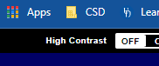

1. Click on CSD ClassLink/Clever.
2. Open E-Hall Pass (student will automatically be logged in).

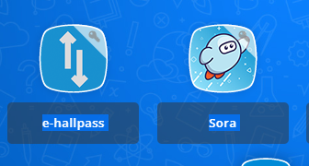

1. Click on “Create Pass” on the menu on the left side of the screen.
2. Look for the DEPARTING FROM heading. Use the drop down “Teacher/Location” to select the current class/room they are leaving from.
3. Look for the DESTINATION heading. Use the drop down “Teacher/Location” to select the class/room they are going to.
4. Then click submit.

For a video demonstration on how to create an e-hallpass watch this short video:

<https://www.google.com/url?q=https://youtu.be/f9mC41Q1zGE&sa=D&source=editors&ust=1661256331002588&usg=AOvVaw3qht6ki69L5tT24skV4cVQ>

Once the student submits the pass, the teacher has 5 minutes to approve the pass or it will be cancelled.